**Movie Management**

Manage Page:

URL : http://localhost:8080/movie-management/MovieManagement.html?

Screenshot:

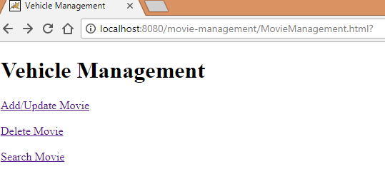

Add/Update Movie

URL: <http://localhost:8080/movie-management/AddMovie.html>

Screenshot:

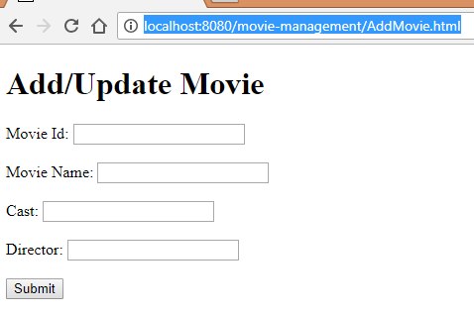

Delete Movie

URL: <http://localhost:8080/movie-management/DeleteMovie.html>

Screenshot:

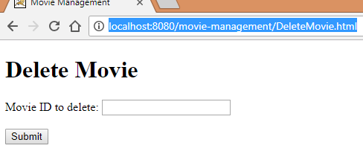

Search Movie

URL: http://localhost:8080/movie-management/SearchMovie.html

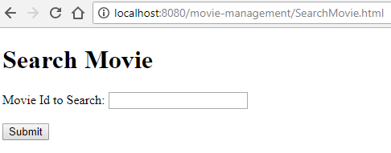

Post CRUD operations

